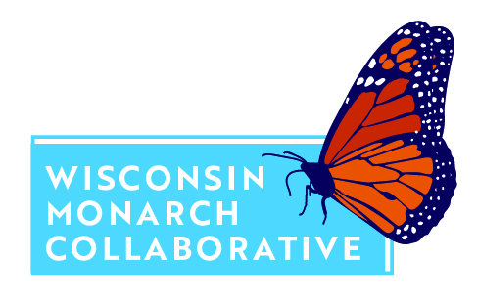
Newsletter Announcement

Monarch butterflies are as essential to summer as lemonade and flip flops. This beautiful, charismatic insect is a popular garden visitor, bringing out the child and the photographer in many of us. But this butterfly is also in major decline, experiencing an approximate 90% drop in population size in just the last 20 years.
Wisconsin is an important part of this beloved butterfly’s summer range, and since we have always been committed to taking good care of the natural resources and species that we have in our state, we want to do what we can do to help reverse this staggering population decline. We are thrilled to announce our partnership with the Wisconsin Monarch Collaborative - a group of businesses, organizations, and individuals who are working together to conserve monarchs in Wisconsin and beyond.
With your help, the Wisconsin Monarch Collaborative is working on implementing a statewide strategy that includes habitat creation and improvement, education, outreach, research, and monitoring. We are proud to be involved with this effort! We have pledged to [insert specific information about what actions your group is taking]. There is a lot of work to be done, but together we can help monarchs thrive in Wisconsin so that future generations can enjoy this incredible species. Make your own pledge to help monarchs this year at wimonarchs.org and click “Pledge.”

For photos to accompany this announcement, please feel free to download images from the photo library (please note that you use must include credit to the photographer if using any images from this page).

